**Description**

As a user, after completing the first part of the Registration form, I should be directed to the next page where it allows me to select which Bank Account

------------------------------------------------------------------------------------------------------------------------------------------

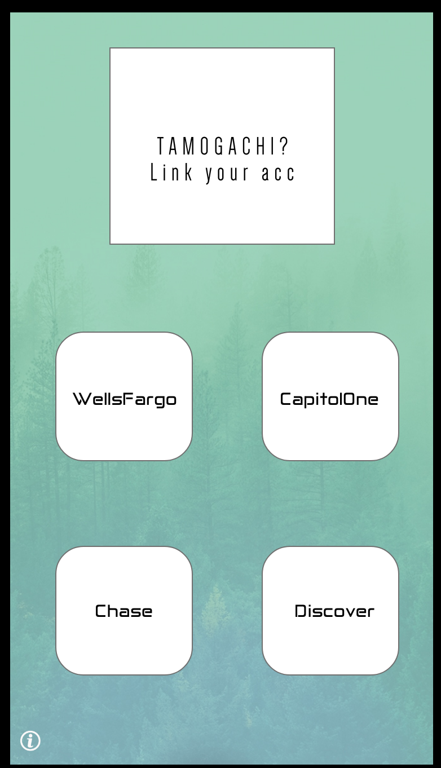

**Acceptance criteria**

* Display 4 Bank options that User can select
* Once user selects their choice of bank, there should be a modal that is populated asking for their login information for to access bank account
* User should be able to hit the sign in button, and the app should be able to generate the financial information from the API Call.
* When user hits sign in, they should be re-directed to the User Dashboard